**Problem 1**

* Temperature Distribution

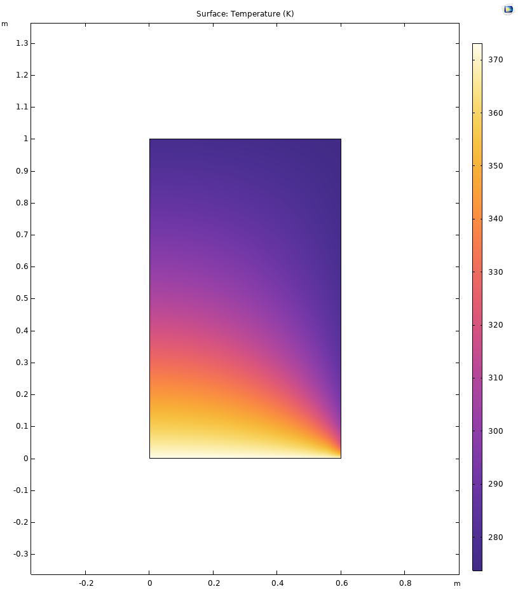

Figure . plot of the temperature distribution

* Temperature at (0.3m,0.1m)

353.22K or 80.07℃

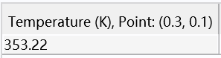

**Problem 2**

* Plot of the distribution of von Mises stress

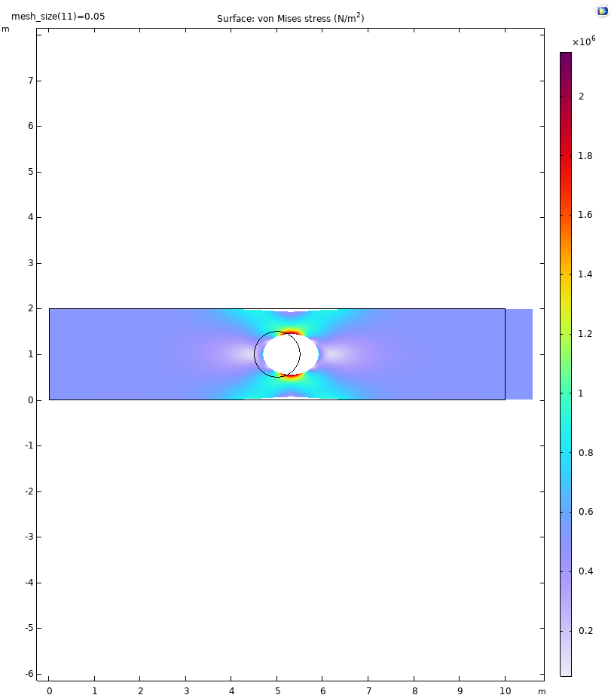

Figure . plot of the distribution of von Mises stress

* Plot of maximum von Mises stress vs. mesh size



Figure . plot of maximum von Mises stress vs. mesh size

The maximum von Mises stress happens at the top and bottom of the hole which can be easily observed from the plot of the distribution of von Mises stress. Thus, four columns (linear elements, bottom of the hole; linear, top; quadratic, bottom; quadratic, top) of data are exported and used to create the figure 3.

From figure 2, We can see that the results based on quadratic elements are stable while the results (von Mises stress) tend to increase and move closer to the result obtained by quadratic elements as the mesh size decreases. From this, I deduce that the results obtained from quadratic elements are very close to convergence, that is to say, relatively accurate results have been obtained. The results obtained by linear elements are still rough, so the results will continue to converge to those of quadratic elements as the mesh size decreases and the computational accuracy increases.

To verify this conjecture, I further reduced the size of mesh size when using linear elements, and obtained two new sets of data using mesh_size/2 and mesh_size/3 respectively and plotted them as shown in figure 4.



Figure . plot of smaller mesh size

As I expected, after reducing the mesh size, the results obtained by using linear elements are further close to those of quadratic elements, thus confirming my suspicion above to some extent.

* Plot of the contours of von Mises stress over the plate

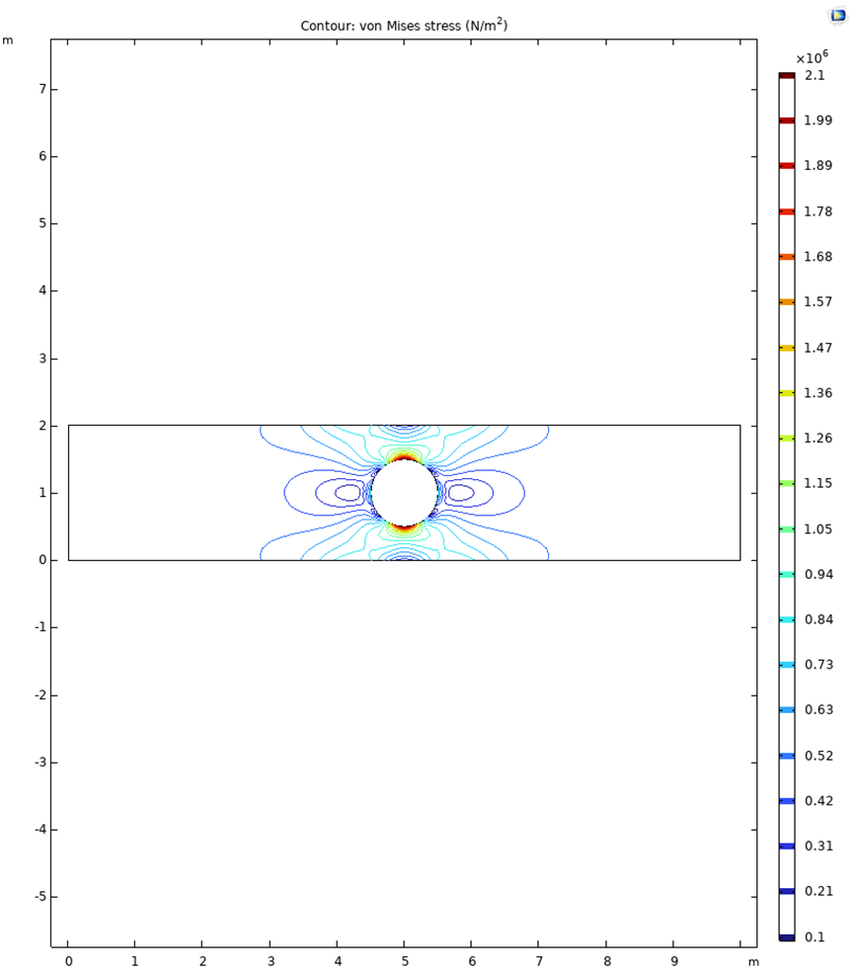

Figure . plot of the contours of von Mises stress